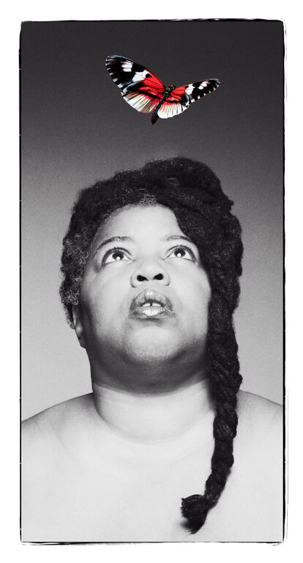

By Cheryl Martin
Co-commissioned by hÅb for Domestic II and The Albany

“Exceptionally good… The poet delivers her material with such energy, charm, emotion and honesty… Food for the soul"
-- The British Theatre Guide
ALASKA
“ I was really impressed… mature and complex work that was being rigorously thought and talked about”
-- Richard Gregory, Quarantine

“In order to be beautiful, you need to be brave”
-- The British Theatre Guide

Alaska is a funny, magical trip to the moon, with singing and dancing thrown in: one woman’s extraordinary story of how she survived growing up with severe depression.
Alaska, the one-woman-show, is inspired by writer-performer Cheryl Martin’s poetry collection, longlisted for the 2015 Polari Prize.
“I called the show ALASKA after a line in a Lou Reed song, Caroline Says II, that goes ‘It’s so cold in Alaska.’ I chose that because most of the time my emotions seem numb, frozen. Then something happens and they wake up.”
A raw and powerful performance, with humour, heart and soul, with stunning vocals and beautiful imagery in the storytelling. With one in four of us estimated to experience mental health difficulties at sometime in our lives, this is a story that touches everyone, whether first-hand or through family and friends.
“It is a devastatingly beautiful show, … poetic narrative and heart achingly profound... absolutely pioneering …people should go”
– Chanje Kunda, performance poet and artist, Manchester Theatre Awards Nominee

Co-commissioned by hÅb for Domestic II and The Albany
Supported by Contact, STUN, Commonword, Arts Council England, PANDA and
Simon Lucas Bridge Supplies

Trailer: https://vimeo.com/144167182
Full length recording of the show at Black Gold Arts Festival, STUN Studio, October 2015:
https://vimeo.com/143696389

BOOKING INFORMATION

Alaska is up close, personal, intense, a path into an entrancing visual world.
Style of work: Small, intimate audience encounter
Company: One performer, Cheryl
Suitability: Festivals; Studio spaces, Small-scale venues, including informal settings such as front rooms, community rooms, houses, hospital wards, Libraries

Minimum Run: 2 shows per day.

Maximum Audience: Tabletop version: 15 per show, 30 per day
Semi-circle / circle: 20-25 per show
Thrust: studio capacity

Tech info: Electrical socket, a light source

Availability: From October 2015

Duration: 45-50 minutes

To check availability and discuss booking Alaska, please contact: Jayne Compton 07803 601 885. For rural venues the show can be extended with a reading from the poetry collection, Alaska and songs (2nd act)

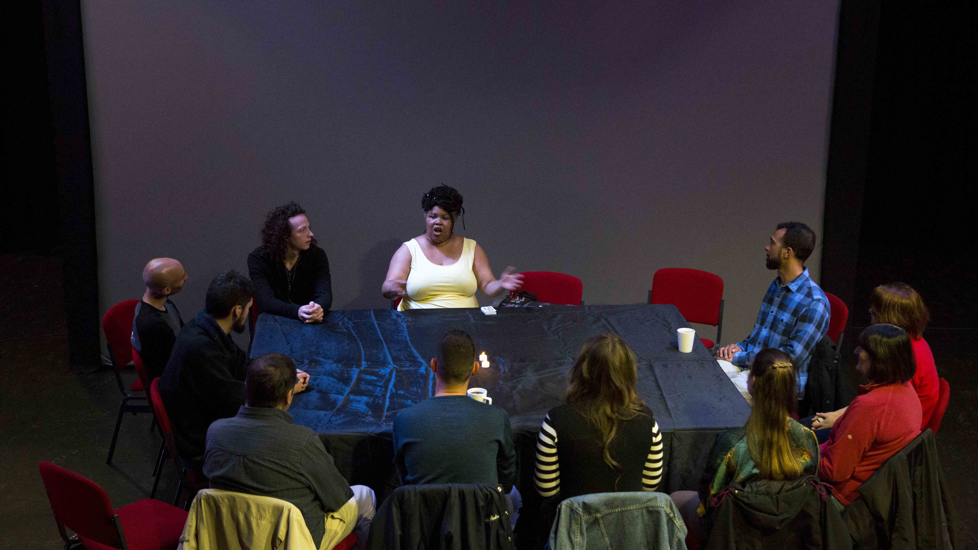
RESIDENCIES AND WORKSHOPS

Cheryl can create and deliver a tailor-made residency package of workshops, residencies, and performances of Alaska.
There could be two forms:
- Workshops

- These could be half-days [3 hours] or full day

- Focus on creating poems or short narratives based on personal experience

- Pay special attention to creating an image-rich world for the audience

- Residencies
- These could be from two/three days to a full week
- Would create work for participants to perform to accompany Alaska
- Focus on finding objects around which personal narratives would be spun
- Examine how to create structure, how to weave fantasy and reality, light and dark
- Look at performance techniques for participants, including vocal improvisation and song

Cheryl’s work with all kinds of performers helps them to find a form and a way of performing that best suits what they want to express. She’s worked with people from pre-school to over 90 years old, and is skilled at creating a safe and supportive atmosphere that enables participants to explore sometimes difficult subjects. Or just to have fun.

Group size: 12 – 20 people

PRESS & AUDIENCE FEEDBACK
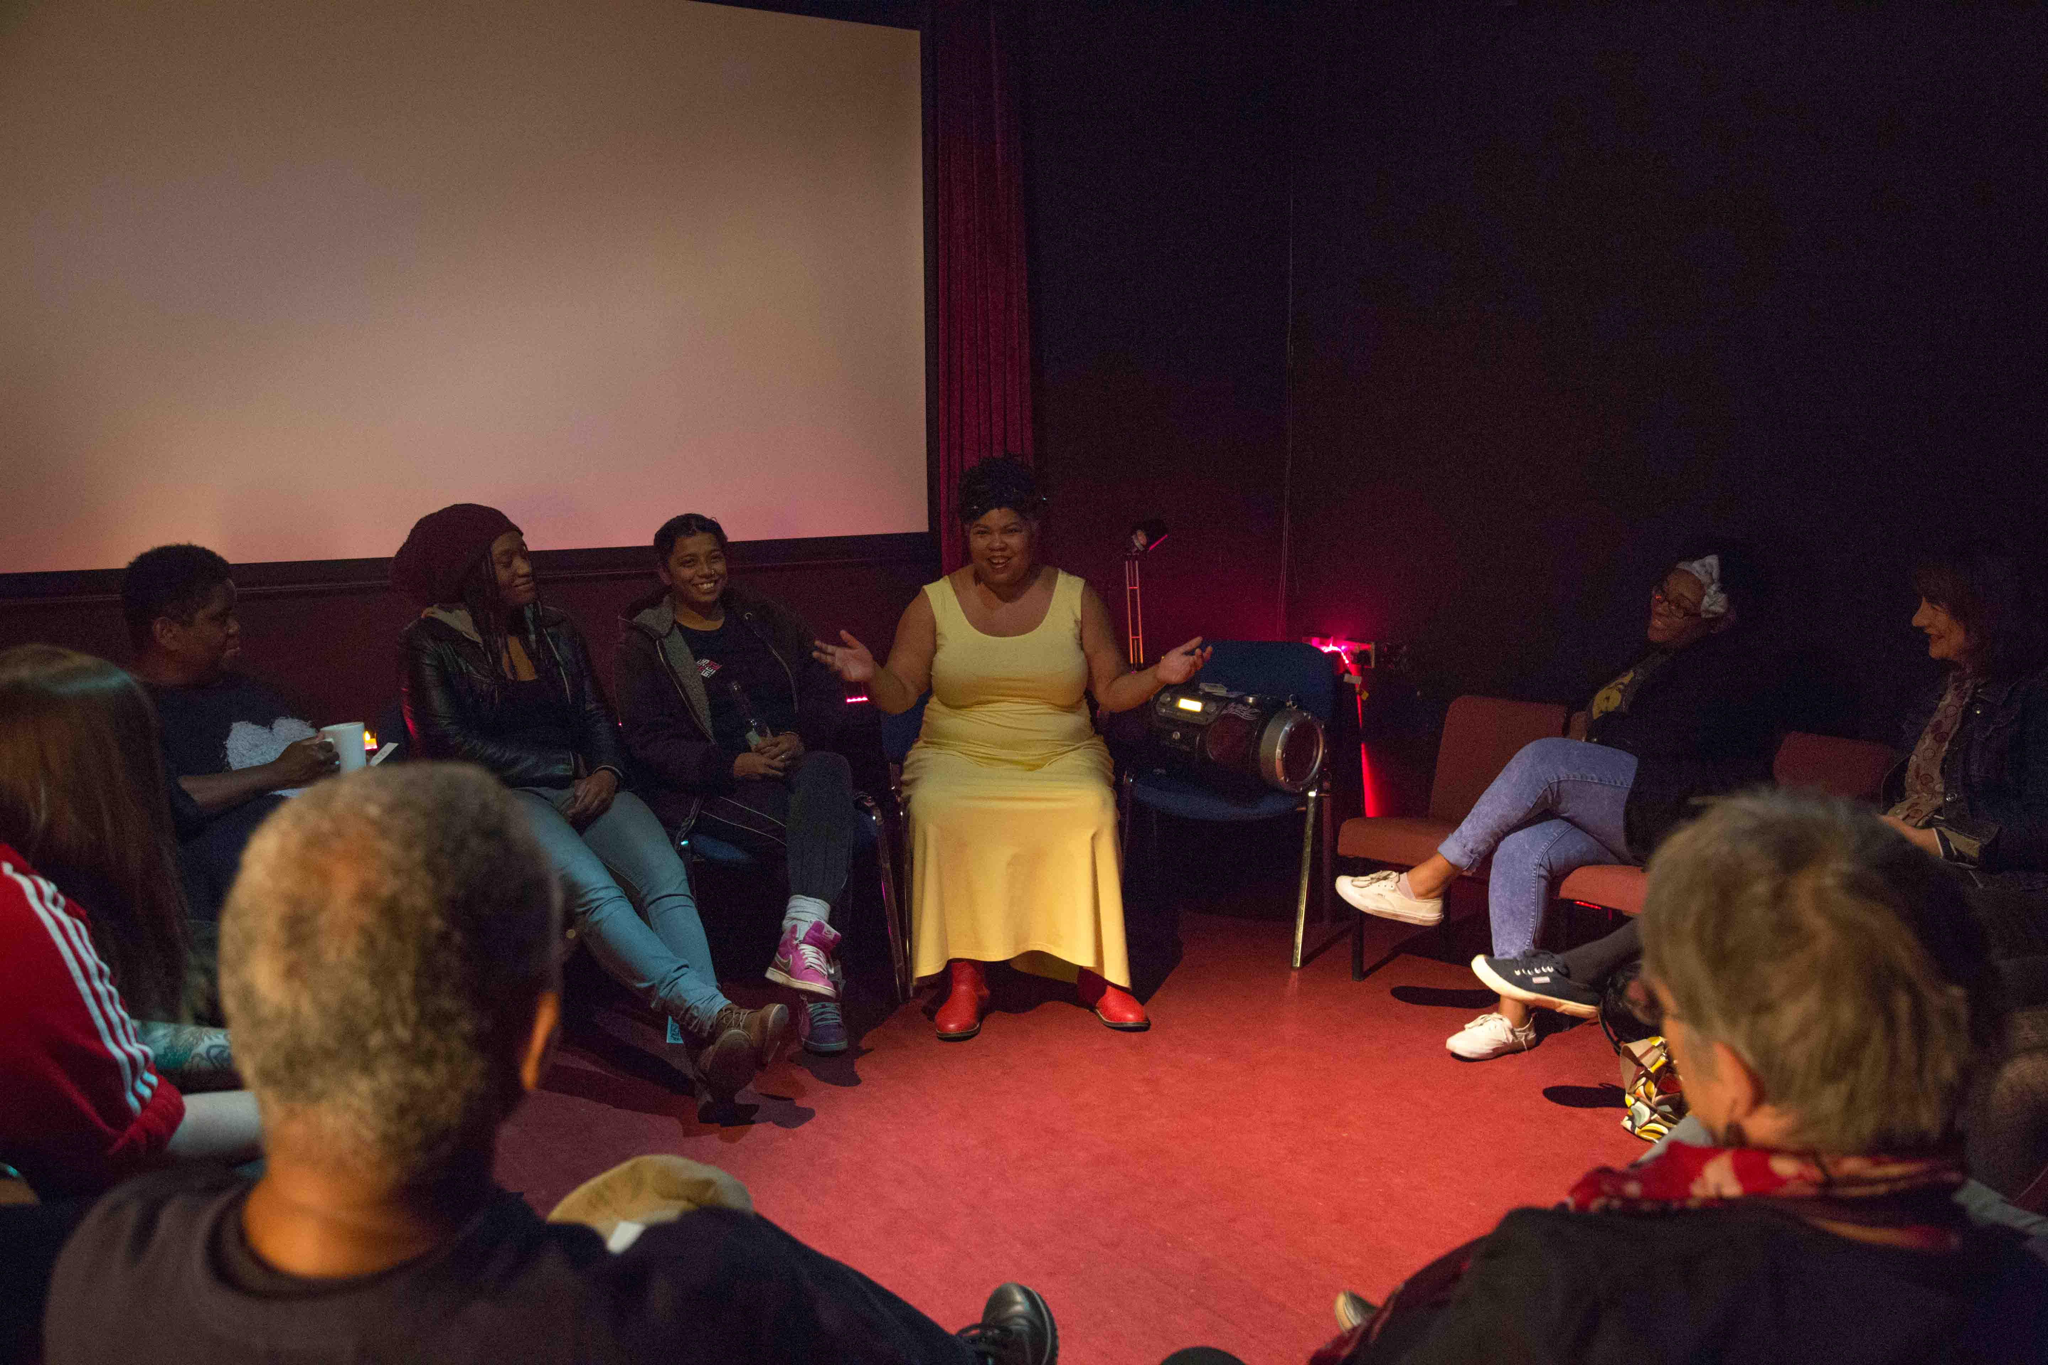

‘Relatable, touching, humorous, engaging - brilliant!'
- Audience member
'The visuals were beautiful and the stories were very touching, insightful, empowering.'
- Audience member
'It was different. I expected poetry; what I got was poetic but so much better.'
- Audience member
“I was left with an overwhelming question 'what does it mean to be well?”
-- Sonia Hughes, Quarantine

“In order to be beautiful, you need to be brave… Exceptionally good… The poet delivers her material with such energy, charm, emotion and honesty… Food for the soul”
-- The British Theatre Guide

‘Cheryl never compromises, she just tells it how it is. A beautiful performance. Brave, courageous, and very powerful. Would like to see more of her work ’
- Audience member

MARKETING
Target audiences: General public 14+, mature audiences, LGBT, mental health professionals, user groups, women prisons, Performing Arts students, BAME especially African descent.

Marketing Resources:
Print: we are able to provide A5 Flyers and A3 Posters
Trailer: https://vimeo.com/144167182
Twitter: @cherylmartinalaska
#alaskatheplay
Facebook: https://www.facebook.com/CherylMartintheatre/

Keywords to promote the show:
Depression, Borderline personality disorder, BPD, Mental Health, suicide, Black theatre,
Black women, jazz, blues, Billie Holiday, Cambridge University.

THE TEAM
Written and Performed by Cheryl Martin

Cheryl Martin was born in Washington, D.C., grew up in nearby Maryland, and went to university at Williams College in Williamstown, Massachusetts in the States and Emmanuel College, Cambridge in England. She loves Manchester, her adopted city.
Cheryl has won Manchester Evening News Theatre Awards as both writer [ Best Community Production, Heart and Soul, Oldham Coliseum and director Best Studio Production, Iron by Rona Munro, Working Girls/Contact, an Edinburgh Fringe First as co-director and producer of Traverse Theatre’s Breakfast Series The World Is Too Much, and this year a Lloyd’s Bank regional award for the immersive play she directed for Community Arts Northwest, Rule 35, and longlisted for the Polari Book Prize for her collection of poems, Alaska Crocus/Commonword, the inspiration for this play.
http://www.cherylmartin.co.uk/about/
Cheryl Martin is a unique voice in today’s theatre, both in her own performances and in the work she makes with others as a director. In both kinds of work, she examines experiences that most people are afraid to talk about, but approaches them with a humour, warmth, and raw honesty that draws audiences in and allows them to explore with her, fearlessly.
Whether directing a writer like Alan Bissett in unearthing Scotland’s uneasy colonial history, or performing in her one-person show, ALASKA, to unearth a personal history of hospitalisation and mental illness, she brings a lightness and wealth of imagery to create worlds audiences love to dwell in.
That relationship with the audience is always key, creating a bond, creating trust, carrying them with you into a world they may think they fear to enter. In many immersive shows created with refugees, she invites the audience to live, for a short time, what other people’s lives feel like. With the joy and the wonder and the beauty that entails, as well as the harsh edges.
Director: Darren Pritchard –- www.darrenpritcharddance.com
Darren has a track record working with poets at Contact, as a performer with Quarantine [SUSAN + DARREN, GRACE], and the innovative interactive visuals on his own piece, BODY OF LIGHT.

Dramaturg: Matt Fenton –- http://contactmcr.com/staff/executive/matt-fenton/
Matt has a long history at Nuffield Theatre, Lancaster of working with digital art and experimental form, as with his own work IN MAY [Sick Festival 2014].

UP COMING TOUR DATES

Action Transport Theatre Writers Ball
Wed 25 Nov, 8pm, ATT, Whitby Hall, Stanney Lane, Ellesmere Port, CH65 9AE

Hoxton Hall, London
tbc February, 8pm, Hoxton Hall 130 Hoxton St, London N1 6SH
hoxtonhall.co.uk

The Albany, London
Tue 19 April, 7pm & 8.30pm, The Albany, Douglas Way, Deptford London SE8 4AG
thealbany.org.uk

PAST TOUR DATES

Flying Solo Festival 2015, Contact
Tue 5 and Wed 6 May, 9pm Contact, Oxford Road Manchester M15 6JA contactmcr.com/cherylmartin

Domestic II, Word of Warning
Thu 24 – Sat 26 September, 7.30pm and 9pm, 15th Floor Matthias Court, Salford M3 6JD
http://domesticmcr.org/

Cartwheel Arts
3rd October, Rochdale, Touchstone Gallery
http://www.cartwheelarts.org.uk/

Black Gold Arts Festival, Z-arts
Thu 22 October, 3pm and 7pm, STUN Studio, Z-arts, Manchester
http://www.z-arts.org/events/alaska/

